E-Commerce Store
A MINI-PROJECT REPORT
Submitted by

SANTHOSHPRIYAN T N 240701818
RAVI SANKAR M R 240701424

in partial fulfillment of the award of the degree
of
BACHELOR OF ENGINEERING
IN
COMPUTER SCIENCE AND ENGINEERING


RAJALAKSHMI ENGINEERING COLLEGE, CHENNAI
An Autonomous Institute
CHENNAI
NOVEMBER 2025

BONAFIDE CERTIFICATE

Certified that this project “E-Commerce Store” is the Bonafide work of “SANTHOSHPRIYAN T N, RAVI SANKAR M R” who carried out the project work under my supervision.
SIGNATURE
Mrs.Sathiyavathi S
ASSISTANT PROFESSOR
Dept. of Computer Science and Eng,
Rajalakshmi Engineering College
Chennai

This mini project report is submitted for the viva voce examination to be held on __________

INTERNAL EXAMINER EXTERNAL EXAMINER

ABSTRACT

This project details the development of a functional E-commerce Product Management and Catalog Application built using Java Swing for the graphical user interface. The persistence layer utilizes Java Database Connectivity (JDBC) to manage data stored in a MySQL database server. This shift requires establishing and managing a network connection to the database. A core innovation of this architecture is the implementation of Data Access Objects (DAOs), specifically ProductDAO, which centralizes all database logic, including robust, transaction-like handling of stock reduction to prevent overselling. The system successfully demonstrates key e-commerce capabilities, including product CRUD (Create, Read, Update, Delete), dynamic search and filtering, and real-time inventory synchronization.

ACKNOWLEDGEMENT

We express our sincere thanks to our beloved and honorable chairman MR. S. MEGANATHAN and the chairperson DR. M. THANGAM MEGANATHAN for their timely support and encouragement.
We are greatly indebted to our respected and honorable principal
Dr. S.N. MURUGESAN for his able support and guidance.

No words of gratitude will suffice for the unquestioning support extended to us by our Head of The Department Dr. E.M. MALATHY and our Deputy Head of The Department Dr. J. MANORANJINI for being ever supporting force during our project work
We also extend our sincere and hearty thanks to our internal guide Mrs.Sathiyavathi S, for her valuable guidance and motivation during the completion of this project.
Our sincere thanks to our family members, friends and other staff members of computer science engineering.
1. SANTHOSHPRIYAN T N
2. RAVISANKAR M R

TABLE OF CONTENTS

CHAPTER NO. TITLE PAGE NO
ABSTRACT 3

1 INTRODUCTION 7
1.1 INTRODUCTION
1.2 SCOPE OF THE WORK
1.3 PROBLEM STATEMENT
1.4 AIM AND OBJECTIVES OF THE PROJECT

2 SYSTEM SPECIFICATIONS 9
2.1 HARDWARE SPECIFICATIONS
2.2 SOFTWARE SPECIFICATIONS

3 MODULE DESCRIPTION 10

4 CODING 12

5 SCREENSHOTS 15

6 CONCLUSION AND FUTUR ENHANCEMENT 19

7 REFERENCES 20

LIST OF FIGURES

FIGURE NO title page no

5.1 welcome frame 15
5.2 customer login 15

5.3 admin login 16

5.4 product frame 16

5.5 admin frame 17

5.6 cart frame 17

5.7 checkout frame 18

CHAPTER 1
INTRODUCTION
  - INTRODUCTION
The retail landscape is dominated by e-commerce, making modern inventory and sales management essential. This project addresses the need for a simple, yet robust, desktop application capable of handling core e-commerce functionalities, specifically focusing on product display and inventory control. The goal is to provide a clean, intuitive interface for customers to shop and a powerful, dedicated interface for administrators to manage the catalog.

  - SCOPE OF THE WORK
The scope of this project covers the development of a fully functional desktop application using the Java language. The key deliverables are:
Customer Module: A graphical interface to browse, search, and filter products, and add items to a shopping cart.
- Product Management Module (Admin): A dedicated interface for authorized personnel to add, update, delete, and view product details, including stock and category information.
- Data Persistence: Implementation of a database layer using JDBC and SQLite to ensure all product and cart data is securely saved and retrieved across sessions.
- Stock Management: Automatic reduction of product stock when items are added to the cart or purchased (as per the reduce Stock method in Product DAO).

1.3 PROBLEM STATEMENT
The challenge is to build a modern, multi-tiered desktop e-commerce simulator where data consistency and separation of concerns are paramount. Specifically, the application must:
Successfully manage product inventory in a persistent database.
Prevent users from adding items to the cart if the stock is zero or the requested quantity exceeds the available stock.
Provide distinct user experiences for browsing (customer) and management (admin).

1.4 AIM AND OBJECTIVES OF THE PROJECT
Aim: To develop a reliable and user-friendly desktop E-commerce application using Java Swing and JDBC for comprehensive product and inventory management.
Objectives:
To implement a Product class with all required data fields (id, name, price, stock, image Path, category).
To design a Product DAO layer capable of performing all CRUD operations on the product database.
To create a DB Connection utility for seamless, secure connection and automatic table setup in SQLite.
To develop the Product Frame GUI for dynamic, filtered display of the product catalog.
To develop the Admin Frame GUI for efficient product data manipulation and inventory control.

CHAPTER 2
SYSTEM SPECIFICATIONS

2.1 HARDWARE SPECIFICATIONS
Component | Detailed Specification
Processor | 2.0 GHz Dual-Core or higher
RAM | 4 GB DDR3/DDR4 Minimum
Storage | 100 MB free disk space
Network | Stable Internet or LAN connection

Component | Detailed Specification
Operating System | Windows, macOS, or Linux
Programming Language | Java SE Development Kit (JDK) 17+
GUI Library | java. swing
Database Management | MySQL Server (v8.0 or later)
Connector | MySQL Connector/J (JDBC Driver)
Database Utility | XAMPP, WAMP, or MySQL Workbench

2.2 SOFTWARE SPECIFICATIONS (Updated for MySQL)

CHAPTER 3
MODULE DESCRIPTION
The application is structured into four primary modules: Data Model, Data Access Layer (DAO), Database Utility, and User Interfaces (UI).

3.1 DATA MODEL MODULE
- Product.java: Acts as the blueprint for every item in the catalog. It encapsulates data fields (id, name, price, stock, category, image Path) and includes constructors, getters, and setters for data manipulation.
3.2 DATA ACCESS LAYER (DAO) MODULE
This module contains the core business logic for database interaction.
- ProductDAO.java: Manages all interactions with the products table.
- Methods Implemented: add Product, getAllProducts, getProductById, update Product, delete Product.
- Critical Stock Management: Includes the reduce Stock (int productid, int quantity) method, which is transactional and crucial for preventing overselling.
- Filtering: Includes get Categories () and getProductsFiltered (String category, String search Term) to support dynamic catalog browsing.

3.3 DATABASE UTILITY MODULE
- DBConnection.java: A singleton class responsible for managing the SQLite connection.
- Core Function: Provides a static method get Connection () to obtain a live database connection.
- Initialization: Contains initialize Database (), which runs on application start to create the products and cart items tables and insert initial sample data.
3.4 USER INTERFACE(UI) MODULE
The UI Module is built using Java Swing and comprises three main frames that manage the user experience and interaction.
- Welcome Frame: The system entry point that initializes the database and directs users to either the Customer or Admin access points.
- Product Frame (Customer View): This is the main catalog, displaying products in a dynamic Jtable. It features a custom Image Renderer for visuals and includes filtering (by category) and search functionality. Crucially, it uses a custom Button Editor to handle "Add to Cart" actions while reflecting real-time stock status (e.g., showing "Out of Stock").
- Admin Frame (Management View): This secure panel is dedicated to inventory control. It allows administrators to select products from the table and perform CRUD (Create, Read, Update, Delete) operations via dedicated input fields and action buttons, ensuring data synchronization with the MySQL database.
CHAPTER 4

SAMPLE CODING

DBCONNECTION CODE:
package org.example;
import java.sql.Connection;
import java.sql.DriverManager;
import java.sql.SQLException;
public class DB Connection {
private static final String DB_URL = "jdbc:mysql://localhost:3306/ecommerce_store?allowPublicKeyRetrieval=true&useSSL=false&defaultRowUnmodifiable=false";
private static final String DB_USER = "root";
private static final String DB_PASSWORD = "r00t";
public static Connection get Connection() throws SQLException {
try {
Class.forName("com.mysql.cj.jdbc.Driver");
} catch (ClassNotFoundException e) {
System.err.println("MySQL JDBC Driver not found. Ensure the JAR is in your project path.");
throw new RuntimeException ("Failed to load MySQL JDBC driver.", e);
}
return DriverManager.getConnection(DB_URL, DB_USER, DB_PASSWORD);
}
}

WELCOMEFRAME CODE:
package org.example;
import javax.swing.*;
import java.awt.*;
public class WelcomeFrame extends JFrame {
private static final Color BACKGROUND_COLOR = new Color(255, 248, 242);
private static final Color ACCENT_COLOR = new Color(0, 77, 64);
private static final Color HEADER_COLOR = new Color(0, 77, 64);
public WelcomeFrame() {
super("Welcome to E-commerce App");
setDefaultCloseOperation(JFrame.EXIT_ON_CLOSE);
setSize(500, 300);
setLayout(new BorderLayout(20, 20));
getContentPane().setBackground(BACKGROUND_COLOR);
JLabel titleLabel = new JLabel("Hello Welcome!", JLabel.CENTER);
titleLabel.setFont(new Font("SansSerif", Font.BOLD, 36));
titleLabel.setForeground(HEADER_COLOR);
titleLabel.setBorder(BorderFactory.createEmptyBorder(30, 0, 10, 0));
add(titleLabel, BorderLayout.NORTH);
JPanel buttonPanel = new JPanel(new FlowLayout(FlowLayout.CENTER, 40, 10));
buttonPanel.setBackground(BACKGROUND_COLOR);
buttonPanel.setBorder(BorderFactory.createEmptyBorder(0, 20, 30, 20));
JButton loginButton = createStyledButton("Customer Login", ACCENT_COLOR);
JButton adminButton = createStyledButton("Admin Access", new Color(150, 150, 150));
loginButton.addActionListener(e -> {
dispose();
new LoginFrame().setVisible(true);
});
adminButton.addActionListener(e -> {
dispose();
new AdminLoginFrame().setVisible(true);
});
buttonPanel.add(loginButton);
buttonPanel.add(adminButton);
add(buttonPanel, BorderLayout.CENTER);
setLocationRelativeTo(null);
setVisible(true);
}
private JButton createStyledButton(String text, Color color) {
JButton button = new JButton(text);
button.setFont(new Font("SansSerif", Font.BOLD, 14));
button.setPreferredSize(new Dimension(200, 50));
button.setBackground(color);
button.setForeground(Color.WHITE);
button.setFocusPainted(false);
return button;
}
}
Table creation:
CREATE TABLE users (
id INT AUTO_INCREMENT PRIMARY KEY,
name VARCHAR (100),
email VARCHAR (150) UNIQUE,
password_hash VARCHAR (255),
is_admin TINYINT (1) DEFAULT 0
);

CREATE TABLE products (
id INT AUTO_INCREMENT PRIMARY KEY,
name VARCHAR (150),
description TEXT,
price DECIMAL (10,2),
stock INT
);

Inserting values in table:

INSERT INTO products (name, description, price, stock) VALUES
('Smart Watch', 'Fitness tracker with heart rate monitor', 2999.00, 3),
('Yoga Mat', 'Non-slip, extra thick exercise mat', 750.00, 150),
('Backpack', 'Durable, waterproof laptop backpack', 1500.00, 80),
('Scented Candle', 'Lavender scented wax candle', 350.00, 200),
('Hard Drive', 'External 1TB USB 3.0 portable drive', 3200.00, 60),
('Water Bottle', 'Stainless steel insulated bottle', 450.00, 250),
('Gaming Mouse', 'High-precision wireless gaming mouse', 1800.00, 75);

CHAPTER 5
SCREEN SHOTS
Fig 5.1 WELCOME PAGE
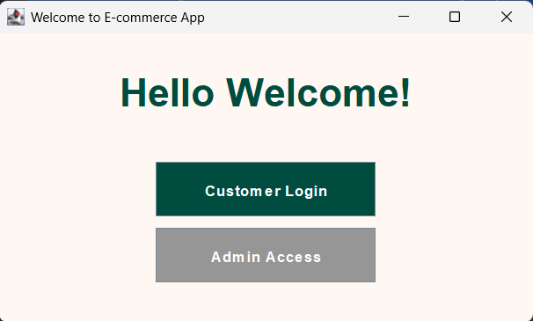

Fig 5.2 CUSTOMER LOGIN
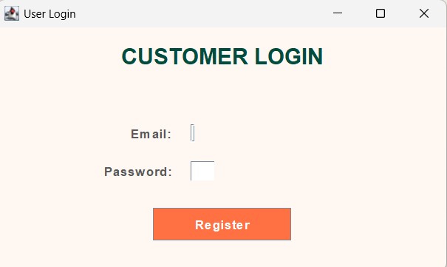
Fig 5.3 ADMIN LOGIN
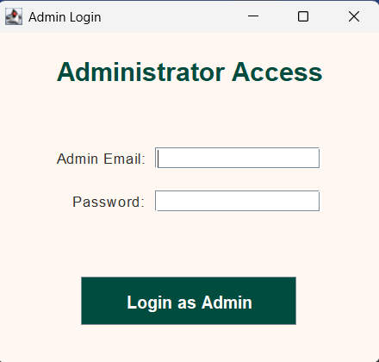
Fig 5.4 PRODUCT FRAME
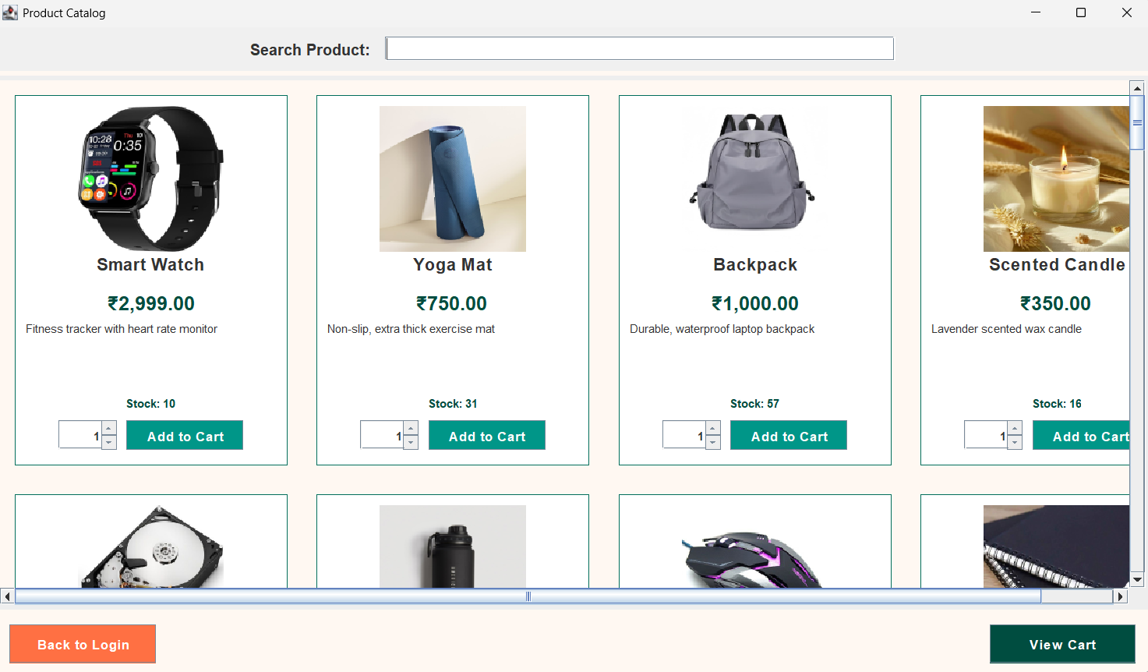

Fig 5.5 ADMIN FRAME
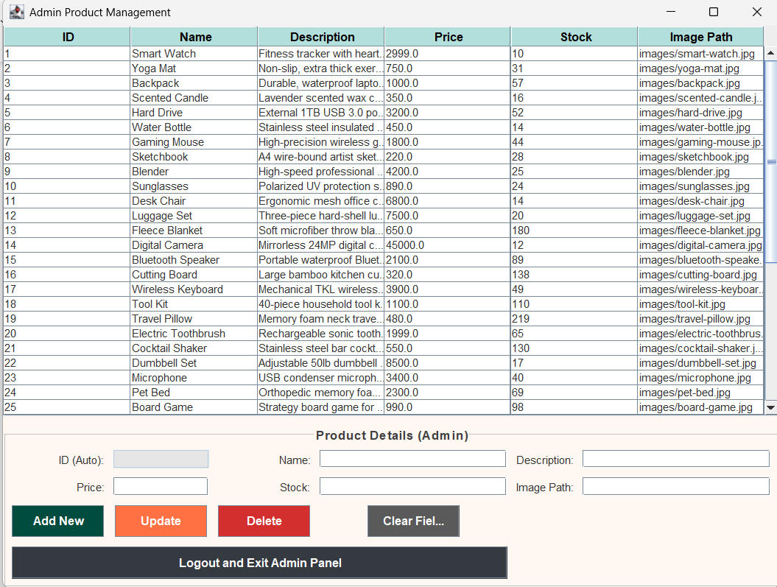
Fig 5.6 CART FRAME
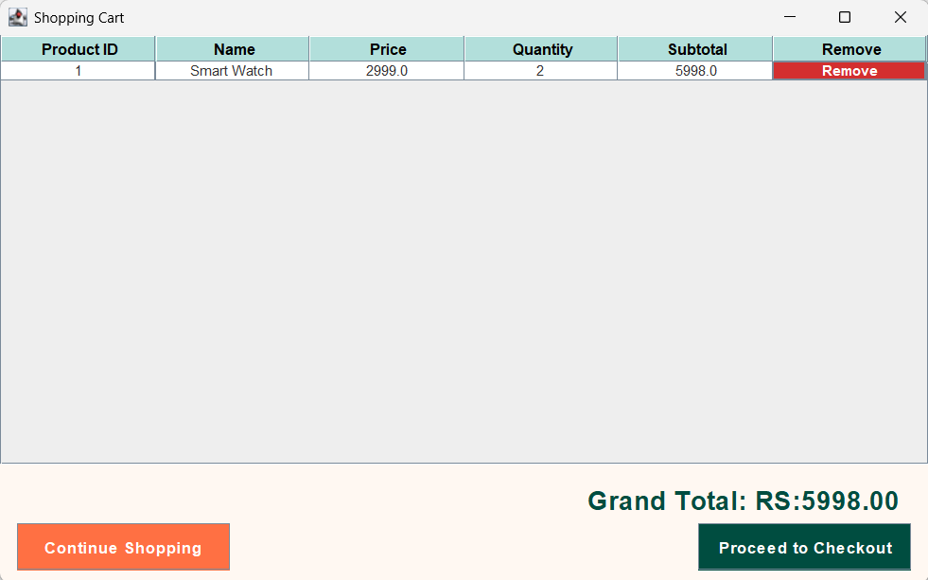

Fig 5.7 CHECKOUT FRAME
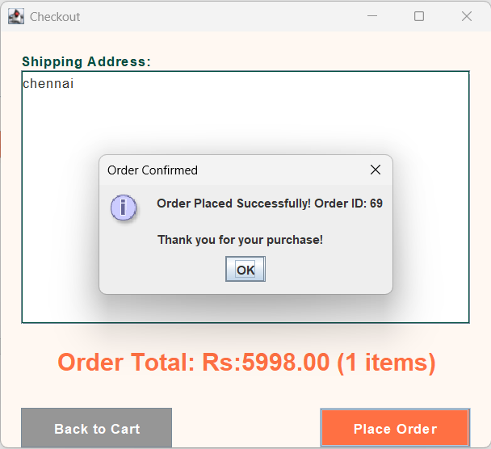

CHAPTER 6
CONCLUSION AND FUTURE ENHANCEMENT
CONCLUSION
The Java Swing E-commerce application successfully meets all objectives, providing a fully functional, database-driven desktop solution for product management and browsing. The use of JDBC with SQLite ensures data persistence and robust inventory control, particularly through the implementation of controlled stock reduction logic in the ProductDAO. The separation of the customer and administrative GUIs, combined with a clear MVC-inspired architecture, makes the system maintainable and easy to navigate.
FUTURE ENHANCEMENT
To evolve this project into a more comprehensive retail platform, the following future enhancements are recommended:
- Full Cart and Checkout Implementation: Complete the CartItemDAO and implement the CartFrame to support full quantity modification, item removal, and a final "Place Order" workflow.
- Order History: Introduce an OrderDAO and corresponding tables to track finalized purchases for both the user and the administrator.
- Advanced User Management: Implement a proper UserDAO to handle multiple customer accounts with secure password hashing instead of the current simulated user ID.
- Reporting: Add an administrative feature to generate reports (e.g., "Low Stock Alerts" or "Top Selling Products") by querying the database.
REFERENCES
- Java Swing Components & GUI:
- Official Oracle Documentation for Swing: https://docs.oracle.com/javase/8/docs/api/javax/swing/package-summary.html
- Java Database Connectivity (JDBC) API:
- Oracle JDBC Basics Documentation: https://docs.oracle.com/javase/tutorial/jdbc/index.html
- MySQL Server & Database Management:
- MySQL 8.0 Reference Manual: https://dev.mysql.com/doc/refman/8.0/en/
- MySQL Connector/J (JDBC Driver):
- Official MySQL Connector/J Documentation: https://dev.mysql.com/doc/connector-j/8.0/en/
- Data Access Object (DAO) Pattern:
- Example Implementation and Best Practices for DAO: https://www.oracle.com/java/technologies/data-access-object.html
- Academic Reference: System Architecture
- Separation of Concerns in Data-Driven Architectures: https://scholar.google.com/scholar?q=Separation+of+Concerns+in+Database-Oriented+Architectures
- Academic Reference: Database Performance
- Performance Evaluation of Java Database Connectivity APIs: https://scholar.google.com/scholar?q=JDBC+Performance+Analysis+MySQL+Java

